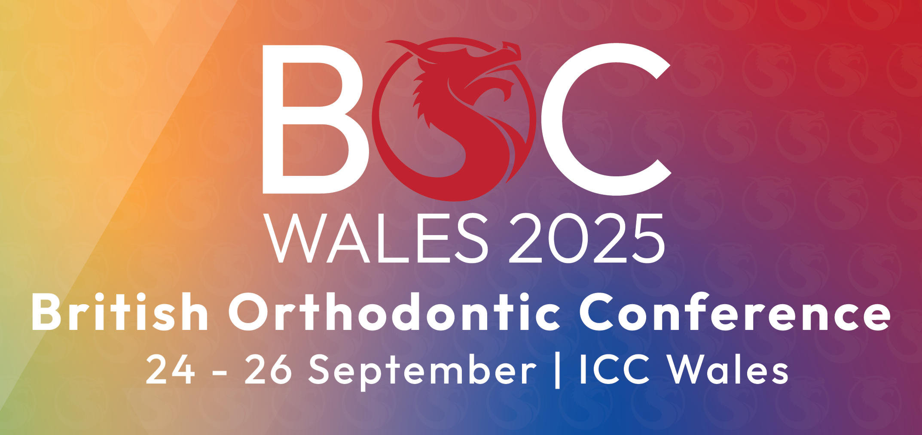

BRITISH ORTHODONTIC CONFERENCE
ICC WALES
24th – 26th SEPTEMBER 2025
SPACE ONLY MAINS & ELECTRICAL EXTRAS ORDER FORM
ORDER & PAYMENT TO BE RECEIVED NO LATER THAN MONDAY 8th SEPTEMBER 2025 TO AVOID A 20% SURCHARGE

DESCRIPTION | COST | QUANTITY | TOTAL CHARGE
6 Amp Single Phase Mains (not 24hr) | £321.40 |  | £
10 Amp Single Phase Mains (not 24hr) | £368.70 |  | £
16 Amp Single Phase Mains (not 24hr) | £439.60 |  | £
20 Amp Single Phase Mains (not 24hr) | £486.90 |  | £
32 Amp Single Phase Mains (not 24hr) | £628.70 |  | £
63 Amp Single Phase Mains (not 24hr) | £995.15 |  | £
PLEASE NOTE
Below are the additional items for hire for all stands that are SPACE ONLY and have ordered mains from above.
*If carrying out your own installation you will need to pay for a ‘Connection to your own distribution board’ and the *test and inspection fee* below. These fees cover works carried out by us to connect your distribution board to the mains supply and test and inspect ALL independent installations, record all readings and advise on any works deemed necessary to ensure that ALL installations comply as required by the venue before the event can go live.
5ft LED Strip Light | £82.40 |  | £
1m Track (for spotlights) | £68.50 |  | £
LED Spotlight (for track) | £39.15 |  | £
Long Arm Spotlight | £82.45 |  | £
Single 500-Watt Socket | £68.10 |  | £
Single 1000-Watt Socket | £82.45 |  | £
Single 2000-Watt Socket | £94.00 |  | £
Single 3000-Watt Socket | £98.35 |  | £
Twin 2000-Watt Socket | £112.00 |  | £
Bond to Metal Structure | £80.95 |  | £
Connection to Client’s Own Equipment/ Distribution Board* | £101.45 |  | £
*Test & Inspection Fee* | £141.30 | £

NET TOTAL | £
20% LATE ORDER SURCHARGE | £
SUB TOTAL | £
VAT | £
TOTAL | £
UK VAT NO. 908 713 320
VAT is payable on all orders delivered in the UK.
Bank Details:
Account No: 74572091 Sort Code: 55-70-01
Account Name: Havills Exhibitions LTD
Swift Code: NWB KGB 2L
IBAN NO: GB 47 NWBK 557001-74572091

Please return your completed form to info@havillexhibitions.co.uk (PDF or WORD format)
*Please note the order and payment deadline dates as specified above to avoid surcharges.

PLEASE SPECIFY METHOD OF PAYMENT: | BACS: |  | CREDIT CARD:
COMPANY: | PO. NO: |  | STAND NO:
ADDRESS:
CONTACT NAME:
TEL NO: | MOBILE:
EMAIL:
ORDER AUTHORISED BY: |  | DATE:

- Please ensure that you provide plans that must show Company Name, Stand Number and Stand Measurements. All working layout plans should be to a reasonable scale, but not less than 1:100. Please submit the drawings and Health and Safety paperwork together with the appropriate forms enclosed with the Manual.
- Please provide the location of sockets and preferred mains supply within your stand plans.

TYPICAL LOADING SUGGESTIONS
Spotlights – 100w to 300w / 0.42 to 1.26amps Computers/Refrigerators – 250w to 500w / 1.05 to 2.10amps
Photocopiers – 2000w to 3000w / 8.4 to 12.6amps Kettles/Coffee Machines – 3000w / 12.6amps

TERMS & CONDITIONS FOR THE SUPPLY OF ELECTRICAL ENERGY & FITTINGS ON HIRE

- Supply 230 volts single phase, 400 volts three-phase 50 cycles alternating current (AC).
- The charges detailed on the price list include for the supply ON HIRE and installation from the electricity power supply, a proportion of the necessary mains cable, overhead/underground network, switch fuse and control gear, together with all necessary circuit wiring and fittings and for taking down and removing at the close of show and standby.
- ALL SUPPLIES will be TURNED OFF AT NIGHT. Should 24hr supply be required you must contact us to arrange before the order deadline date shown OR follow instructions given on the order form.
- The electrical supply will be terminated at the nearest point on the stand to the distribution board. Exhibitors requiring a different termination point should give details on a separate sheet and attach it to the application.
- It is strictly understood that ONE item of equipment only is to be connected to each point. THE USE OF ADAPTORS IS PROHIBITED.
- Exhibitors will be held responsible for any materials, etc, which are damaged or missing at the end of the show AND IT IS THE RESPONSIBILITY OF THE EXHIBITOR TO ENSURE THAT EQUIPMENT IS RETURNED IN GOOD ORDER.
- Applications for the supply must be received by us NOT LATER THAN THE DATE SHOWN ON THE ORDER FORM ABOVE, after which date no guarantee will be given that the work will be carried out, but if it is carried out the cost will be as price list plus the surcharge for modifications to our supply network.
- We reserve the right to refuse to connect to the supply any faulty equipment. Any work carried out on equipment to bring it to the required standard will be charged on a time and material basis and payable in advance.
- THE USE OF PERSONAL GENERATING SETS IS STRICTLY PROHIBITED.
- Supply of electricity should normally be available to most stands from mid-day on the day prior to the show commencing until the official closure of the show. However, should this not be possible, for whatever reason, this Company cannot be held responsible and will NOT accept any claims for loss of earnings or otherwise.
- Refunds for cancellations will only be given if notice of cancellation is received by the Company prior to the deadline for ordering date as stated on the order form above. Where written cancellation is received later than this date the services ordered will be charged at the full rate, as the work is prepared in advance.
- Any portable electrical appliance intended for use at this event must display a valid PAT (Portable Appliance Test) certificate, otherwise power will not be connected.
- Any exhibitor making connections themselves to the network or multiple connections from one stand to the stand of another exhibitor will be immediately cut off from the original supply point and service denied to them.
- Positions of points on your stand will be at a mutually agreed practical position. Alterations may result in further charges.
All electrical equipment fitted to the stand is on hire and will remain the property of Havills Exhibitions Ltd after the exhibition.

