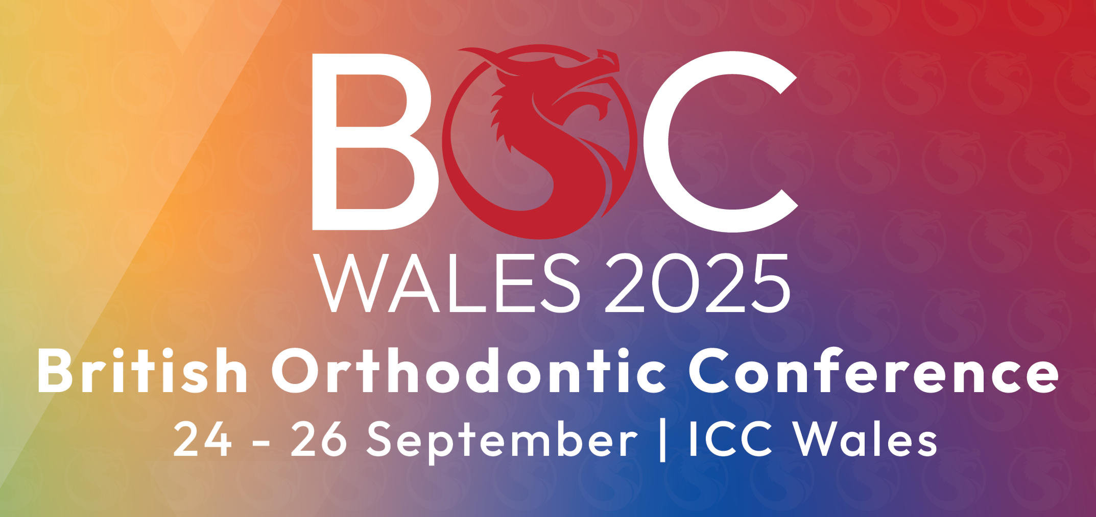
BRITISH ORTHODONTIC CONFERENCE
ICC WALES
24th – 26th SEPTEMBER 2025
HEALTH & SAFETY DECLARATION FORM – ALL EXHIBITORS
It is a condition of entry to the exhibition, that every exhibitor, contractor, sub-contractor and supplier comply with all the requirements of the health & safety & CDM regulations, The Management of Health & Safety at Work Regulations and all other legislation covering the venue and all activities undertaken within or with regard to the event.
Please fill in all the relevant information below.
Our company on site representative with responsibility for Health and Safety will be:
Deadline for completing & returning this form is MONDAY 8th SEPTEMBER 2025 to abbie.milligan@havillsservices.co.uk
Name: | Position:
Company Exhibiting: |  | Stand No:
Address:
 | Email:
Tel: | Site Contact No:
Authorised By: | Signed:
Position: | Date:
Please indicate if any of the following will feature as part of your stand:

- Platforms of 600mm or over YES/NO
- Hazardous substances working mechanical equipment YES/NO
- Hydraulic equipment (static or working) YES/NO
- Food preparation and service YES/NO
- Working at height (using steps, ladders, towers, platforms etc) YES/NO
Our principle stand contractor is (SPACE ONLY)
Contact Name: |  |  | Position:
Address: |  |  | Postcode:
Tel: |  | Site Contact No:
Email:

SHELL SCHEME Company Exhibiting: …………………………………………………………………………. Stand No: ……………………
Risk Assessment: List any significant hazards and control measures that you will be using. Things to consider are slips and trips, manual handling work, work at heights, falling objects, trailing cables.
Hazard | Control Measure

Method Statement: Describe the main processes and actions involved with the build, operation (open period) and dismantling of your stand. Please also include descriptions of the equipment, fittings and devices contained within your stand (laptops, TV monitors, tables, chairs, display boards etc)
Completed by ……………………………………………………………………… Position: ………………………………………………………….
Signature: ……………………………………………………………………………. Date: ………………………………………………………………
Please provide a simple line drawing of the intended layout of your stand showing dimensions and attach to this form.
Please return all documents requested to Abbie Milligan, Event Manager abbie.milligan@havillsservices.co.uk You may be required to provide further clarification of your shell scheme stands design or to make changes to your design to comply with the Health & Safety & CDM regulations requirements of the event.

