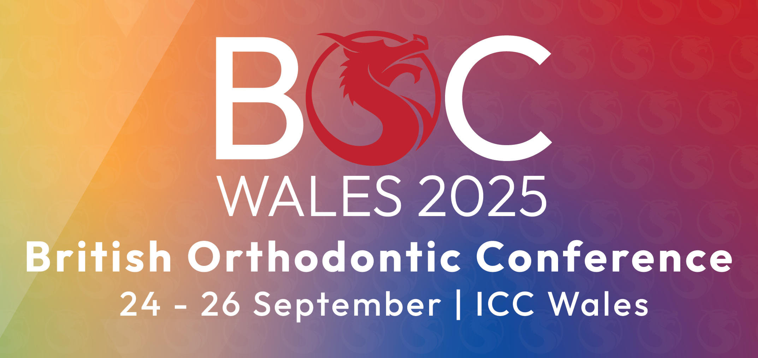
BRITISH ORTHODONTIC CONFERENCE
ICC WALES
24th – 26th SEPTEMBER 2025
MANUAL DECLARATION FORM
I declare I have read and that I understand all relevant parts of the British Orthodontic Conference exhibitions manual and confirm that our principle stand contractor below (if applicable) has been sent all relevant manuals and Health and Safety instructions to comply with.

Deadline for completing & returning this form is MONDAY 1ST SEPTEMBER 2025
Name: | Position:
Company Exhibiting: |  | Stand No:
Address:
 | Email:
Tel: | Site Contact No:
Authorised By: | Signed:
Position: | Date:

Please indicate here if you are shell scheme or space only | SHELL SCHEME [ ] | SPACE ONLY [ ]
It is condition of entry to the exhibition that every exhibitor, contractor, sub-contractor, supplier and their agents comply with the procedures written within the British Orthodontic Society & Havills manual and their order forms.
If you have any queries regarding them or this form please contact Abbie Milligan, Event Manager abbie.milligan@havillsservices.co.uk
Our principle stand contractor is (if applicable)
Contact Name: |  |  | Position:
Address: |  |  | Postcode:
Tel: |  | Site Contact No:
Email:

