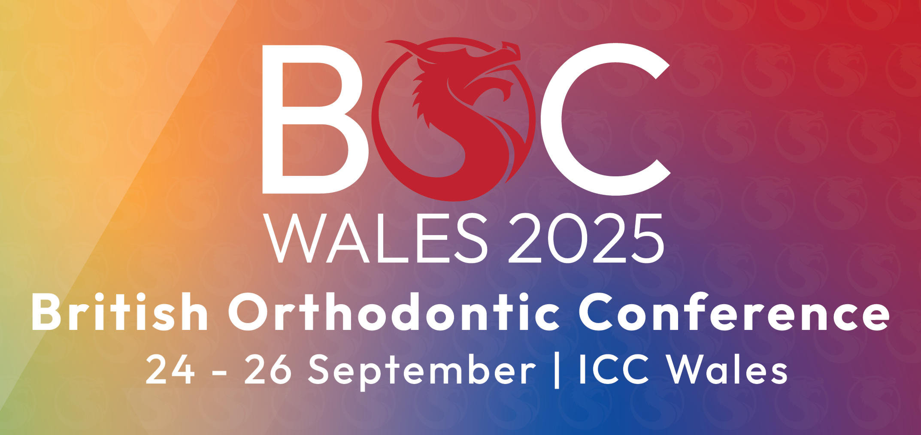

BRITISH ORTHODONTIC CONFERENCE
ICC WALES
24th – 26th SEPTEMBER 2025

SHELL SCHEME STAND – COMPANY NAMEBOARD ORDER FORM
Please return to info@havillexhibitions.co.uk
Deadline: MONDAY 8th SEPTEMBER 2025

Please return your completed form to info@havillexhibitions.co.uk (PDF or WORD format)

COMPANY: |  | STAND NO:
ADDRESS:
CONTACT NAME:
TEL NO: | MOBILE:
EMAIL:
ORDER AUTHORISED BY: | DATE:

Please enter the required COMPANY TITLE (up to 25 characters) below.
No addresses or telephone numbers please.
Only one free of charge per shell scheme stand booked.
If you require additional nameboards, please order using the shell scheme extra fittings form.
Your company title will be produced in a standard lettering style and size.

Company Name:

- - - - - - - - - - - - - - - - - - - - - - - -

